Update Your E-mail Signature
- To update your e-mail signature with the Project Feed Connecticut information, select the link below for insturictions based on your e-mail provider:
- Apple Mail
- Gmail
- Microsoft Outlook
- Outlook.com
- Outlook Web App
- Use the photo titled Project Feed CT-square-small.jpg along with the below text to create your signature:
Donate Today!
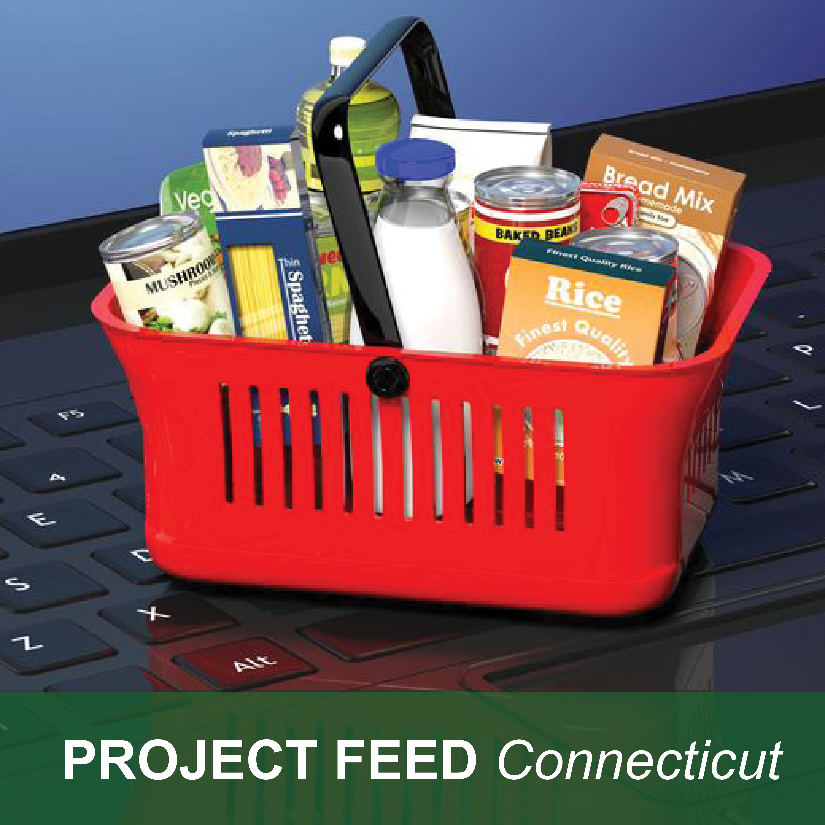
ctbar.org/ProjectFeedCT
#ProjectFeedConnecticut

